EMOTIONAL CLEARING CLASS
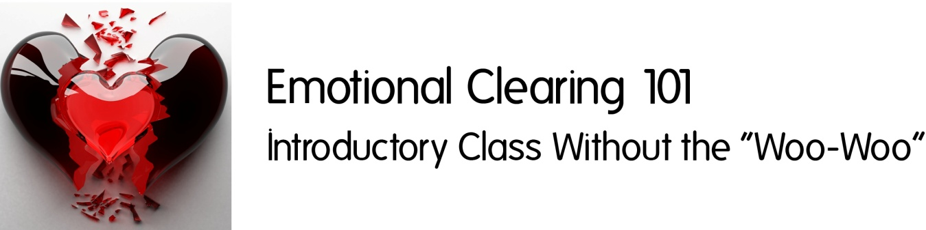

Do you ever do things you really don't want to do, but can't seem to stop yourself from doing? Are there things you really desire to do, but you can't seem to make yourself do them? Do you beat yourself up about it and make yourself wrong?

What if old energy is getting in the way of you creating your life to be the way you'd like it? What if there are some really easy tools to clear away all that old junk and be able to access ALL of you: all of your knowing, your gifts, talents and abilities? And what if you could start creating this ease BEFORE the holiday stress hits?!

Well, all this IS possible, and I'd love to share those tips and tools with you! No "woo-woo", just practical tools you can start using right away to create more ease in your life. In this class, you will learn how to quickly and easily (and painlessly) identify what old, stuck energy is holding you back and clear it away.

In addition to recorded class sessions, you will receive live personal coaching with me, as well as discussion with other class members on our exclusive online venue.

www.HolisticHealthDIY.com

Emotional Clearing 101 Class  www.holistichealthdiy.com | Emotional Clearing 101 Class  www.holistichealthdiy.com | Emotional Clearing 101 Class  www.holistichealthdiy.com | Emotional Clearing 101 Class  www.holistichealthdiy.com | Emotional Clearing 101 Class  www.holistichealthdiy.com | Emotional Clearing 101 Class  www.holistichealthdiy.com | Emotional Clearing 101 Class  www.holistichealthdiy.com | Emotional Clearing 101 Class  www.holistichealthdiy.com | Emotional Clearing 101 Class  www.holistichealthdiy.com | Emotional Clearing 101 Class  www.holistichealthdiy.com | Emotional Clearing 101 Class  www.holistichealthdiy.com | Emotional Clearing 101 Class  www.holistichealthdiy.com

