HOMEOPATHY CLASS
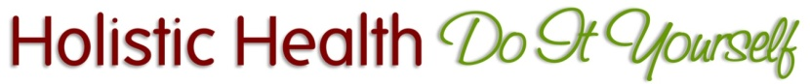
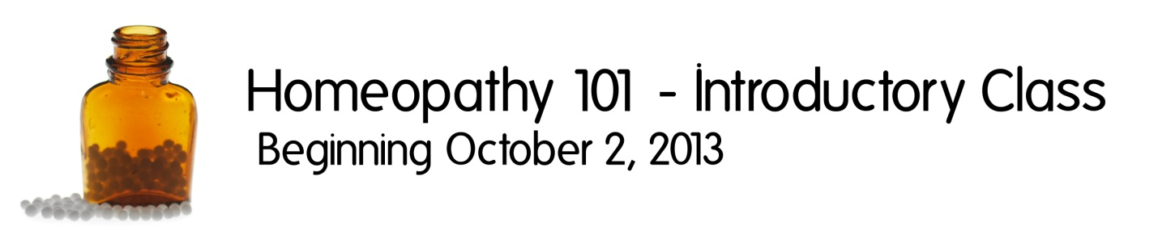

Are you interested in using homeopathy, but aren’t sure where to start? Are you drawn to the safety of homeopathic remedies, but get confused when choosing which remedy to use, or how often to take it? This course will clear all of that up for you and teach you all the basics of successfully using homeopathic remedies in your home. You will learn the best reference books to use and how to assemble a kit with all the remedies you’ll use most often. The basics are pretty simple, but if you don’t understand them, will result in less than desirable outcomes.

The good thing is that you can’t harm anyone with homeopathic remedies, but if you don’t choose and administer them properly, they just won’t work. If you don’t know where to start, or have been frustrated with the results you’ve gotten in the past, this course will answer all of your questions and help you learn to LOVE homeopathy as a major tool in your holistic health toolbox.

This beginning homeopathy class is appropriate for everyone, whether you’re completely new to holistic health, or you’re experienced in other modalities and just want to add this tool to your toolbox. It’s a great place to start AND a great addition to everything else you might already be doing.

www.HolisticHealthDIY.com

Homeopathy 101 Class  www.holistichealthdiy.com | Homeopathy 101 Class  www.holistichealthdiy.com | Homeopathy 101 Class  www.holistichealthdiy.com | Homeopathy 101 Class  www.holistichealthdiy.com | Homeopathy 101 Class  www.holistichealthdiy.com | Homeopathy 101 Class  www.holistichealthdiy.com | Homeopathy 101 Class  www.holistichealthdiy.com | Homeopathy 101 Class  www.holistichealthdiy.com | Homeopathy 101 Class  www.holistichealthdiy.com | Homeopathy 101 Class  www.holistichealthdiy.com | Homeopathy 101 Class  www.holistichealthdiy.com | Homeopathy 101 Class  www.holistichealthdiy.com

